Data Mining
Lab 03

Names:

1) Ahmed Mohamed EL-Bawab (08)

2) Khalil Ismail Khalil (23)

1) Visualization:

a) scatter plot:

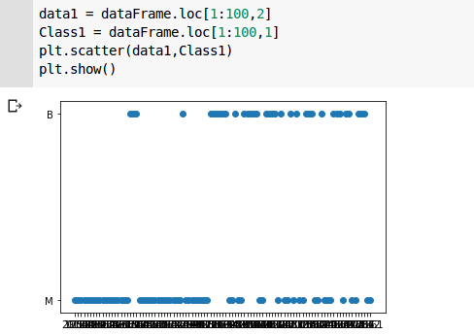

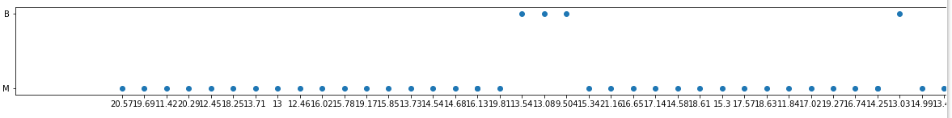
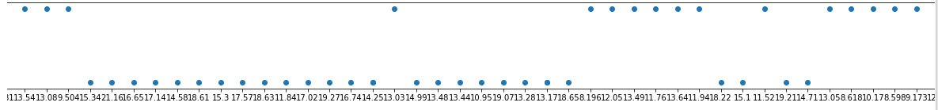

b) box plot:

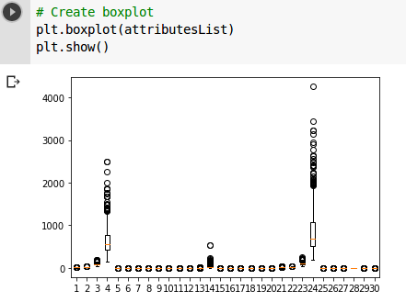

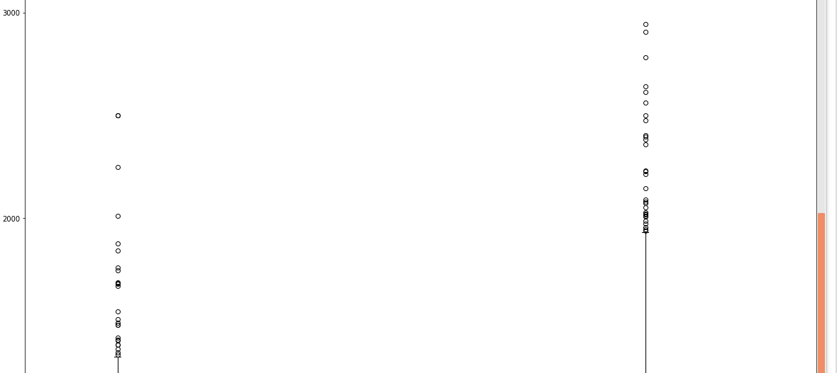
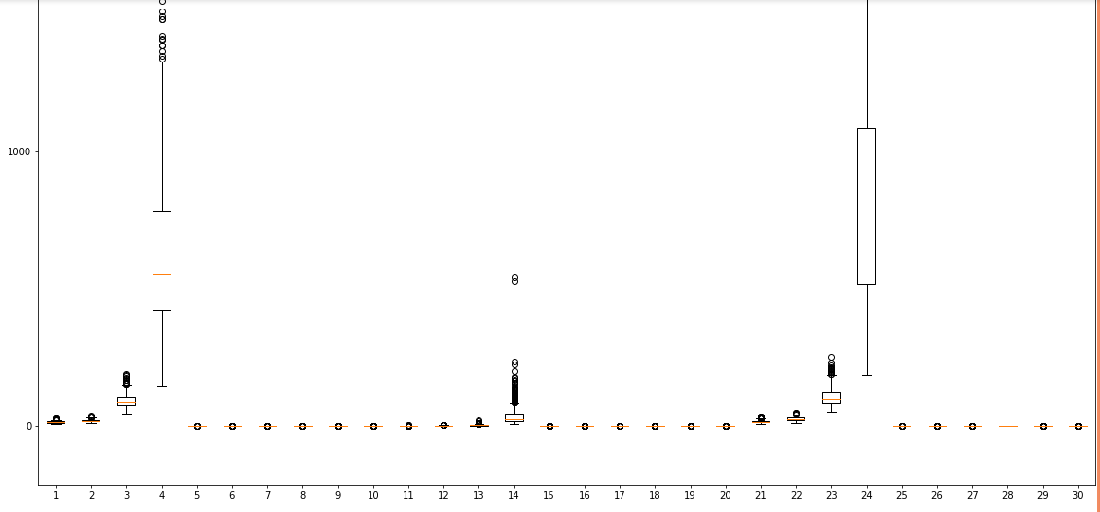

c) correlation matrix imshow:

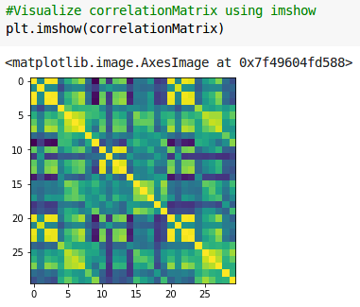

d) histogram plot:
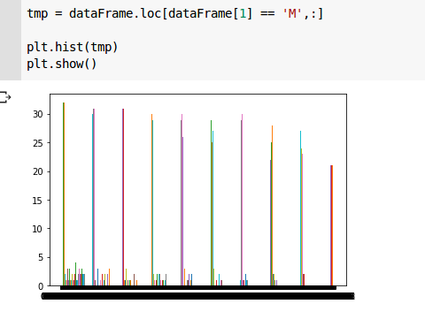

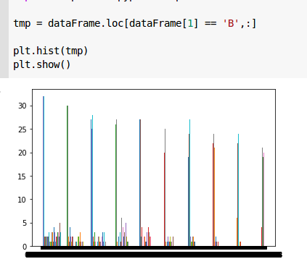

2) Preprocessing:

a) z-score normalization:

- histogram plot before and after normalization:

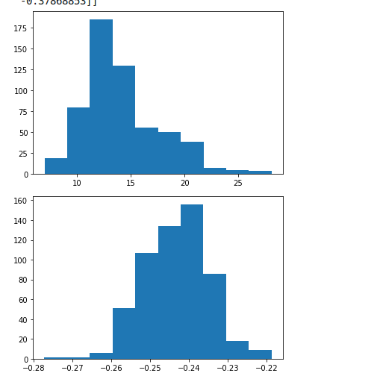

- box plot before and after normalization:
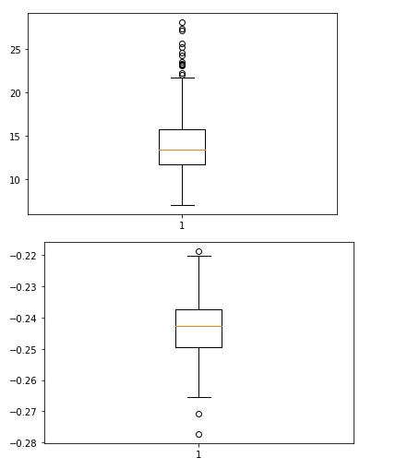

b) feature projection:

- using 2 principal components:
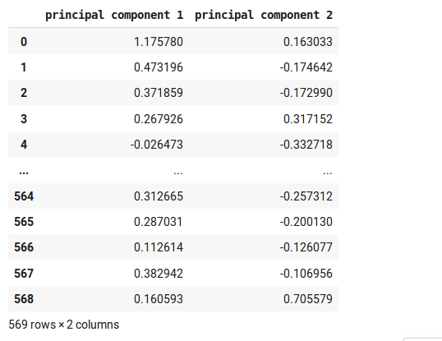

3) Dataset Splitting:

- train data:
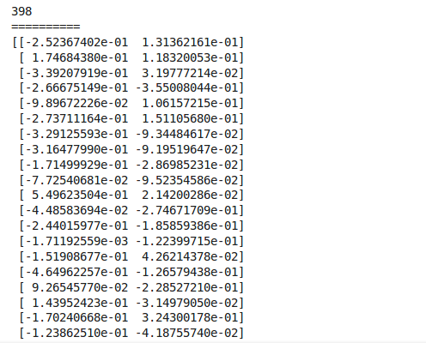
- test data:
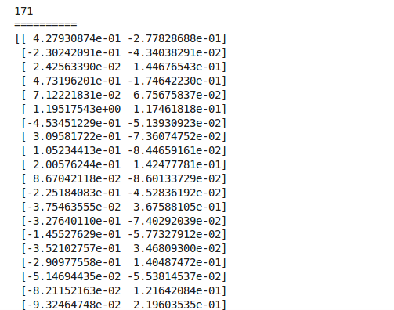
- train class:

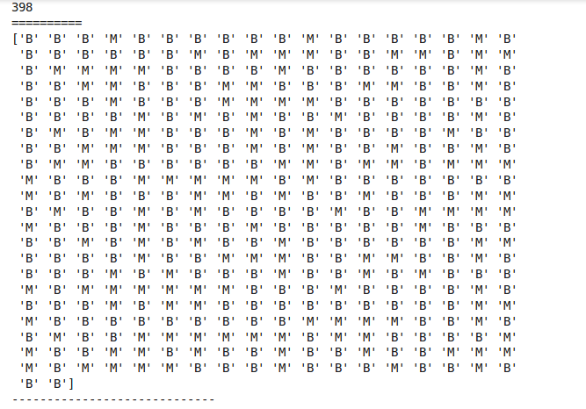

- test class:
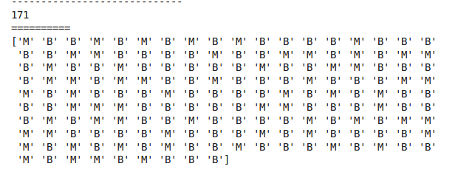

4) Classification:

a) KN-model:

- before using cross validation (best parameters):
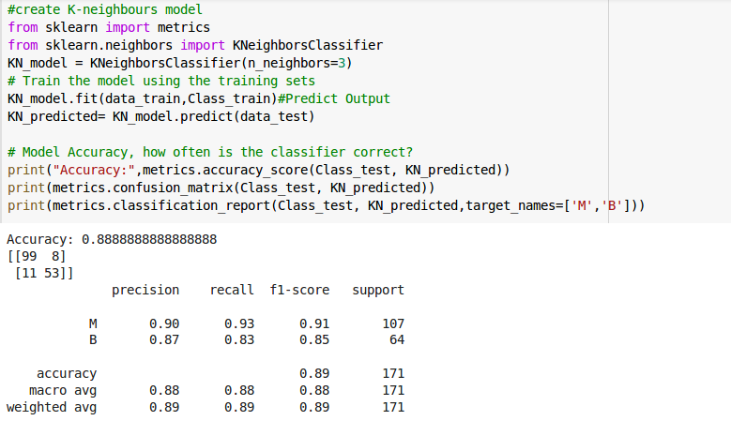
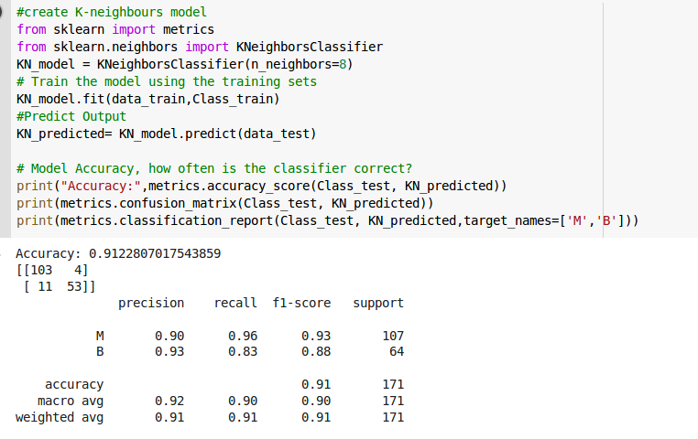
- after using cross validation (best parameters):
b) SVM-model:

- before using cross validation (best parameters):
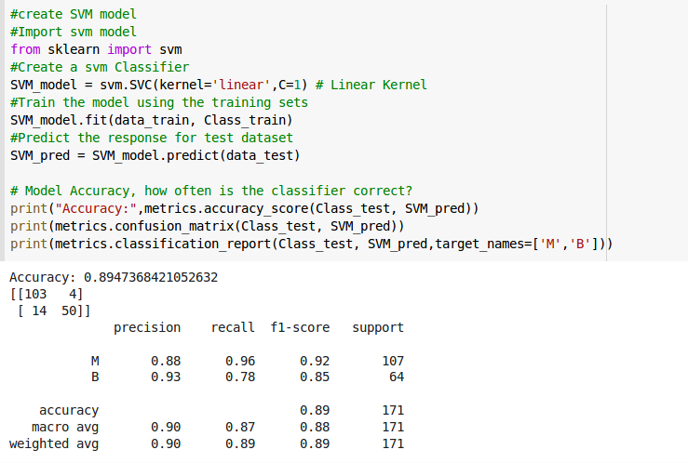
- after using cross validation (best parameters):
c) SVC-model:

- before using cross validation (best parameters):
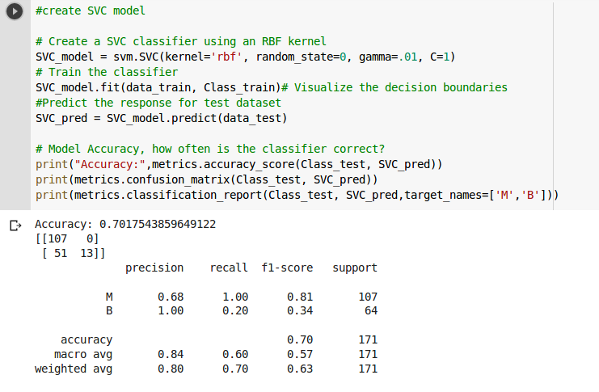
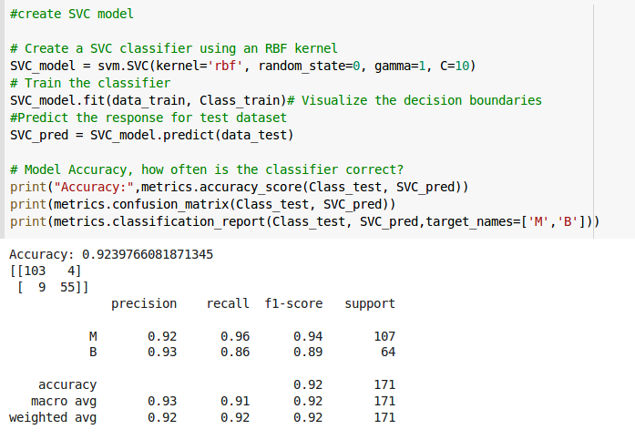
- after using cross validation (best parameters):
d) Logistic Regression-model:

- before using cross validation (best parameters):
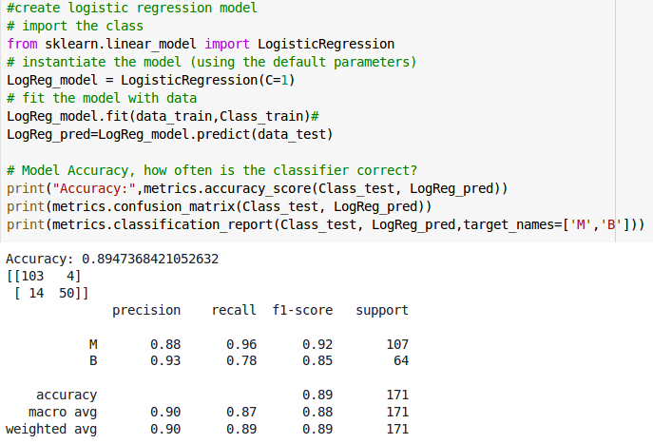
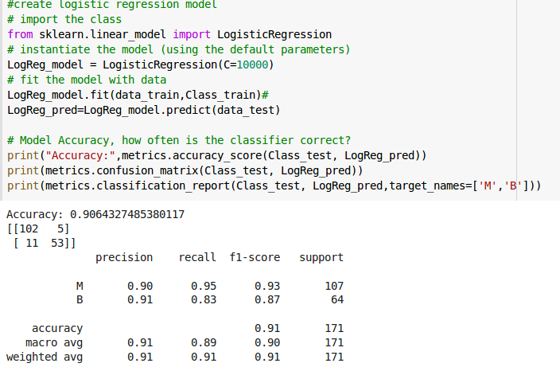
- after using cross validation (best parameters):
5) Cross Validation (best parameters of models):

